

AIML B23- PGCP

Develop An Efficient Retrieval-Augmented Generation (RAG)
Pipeline For Real World Applications

Group -8
Group Members:
Bhagyalakshmi Bikki
Hima Bindu
Sarat Venkata Naresh Maripi
Kesireeddy Pradeep Kumar

Project Mentor: Lokesh, Gopichand
Project Supervisor: Dr.Manish Shrivastava

Feb 22, 2025

Table of Contents

1. Task 1: Real World RAG System Implementation 3
1.1. Introduction to RAG 3
1.2. Problem Statement 4
1.2.1. Foundation on Existing Research 4
1.2.2. Project Goals and Contributions 4
1.3. RAGBench Dataset 5
1.4. Established RAG Workflow 6
1.5. Proposed RAG Pipeline 8
1.5.1. Document Preprocessing 8
1.5.2. Embedding Selection 8
1.5.3. Vector Database Selection and Storage 8
1.5.4. Retrieval Method 8
1.5.4.1. FAISS-Based Approximate Nearest Neighbour Search 8
1.5.4.1.1. Advantages of FAISS Based ANN Retrieval Approach 9
1.5.4.2. Maximal Marginal Relevance (MMR) for Re-Ranking 9
1.5.4.2.1. Advantages of MMR-Based Re-Ranking 10
1.5.5. Response Generation 10
1.5.5.1. LLM Model Selection 10
1.5.5.2. Response Generation Prompt and Hyperparameter Tuning 10
1.5.5.3. Post-Processing the Generated Response 11
1.5.5.4. Advantages of Our Response Generation Approach 11
1.6. Performance Evaluation Metrics 12
1.6.1. Explainability Attributes for Generated Responses 12
1.6.1.1. Post-Processing the Explainability Attributes 12
1.6.2. TRACE Metrics Generation 13
1.6.3. Overall Model Performance 14
1.7. Experiments 15
1.7.1. Models Used Across Experiments 15
1.7.1.1. Model 1 15
1.7.1.2. Model 2 16
1.7.1.3. Model 3 16
1.7.1.4. Model 4 16
1.7.1.5. Model 5 17
1.7.1.6. Results 17
1.8. Challenges 18
1.8.1. Curating the Prompt for Response Generation 18
1.8.2. Post-processing Generated Responses and Explainability Attributes 18
1.8.3. Finding a Suitable LLM with API Interface 19
1.9. RAG Deployment and Applications in Real world 19
2. Task 2: Benchmarking Large Language Models in Retrieval-Augmented Generation 20
2.1. Introduction 20
2.2. Business Use case 20
2.3. Dataset 20
2.4. Data Preprocessing 21
2.5. Model Implementation 21
2.5.1. Noise Robustness Model 22
2.5.2. Rejection Ratio Model 22
2.5.3. Counterfactual Robustness Model 23
2.5.4. Information Integration Model 24
2.6. Evaluation Metrics 24
2.7. Results 26
3. Conclusion 31
4. References 32

1. Task 1: Real World RAG System Implementation

1.1. Introduction to RAG
Large Language Models (LLMs) have revolutionized the field of natural language processing with their ability to generate human-like text. However, they often struggle with challenges such as hallucination (fabricating facts) and reliance on outdated training data. Retrieval-Augmented Generation (RAG) addresses these issues by integrating retrieval-based techniques with generative models. This integration enables the system to dynamically fetch relevant, up-to-date, and domain-specific information during inference, reducing hallucinations, improving the accuracy and reliability of the generated responses.
By combining pretraining with retrieval methods, RAG enhances the contextual awareness of LLMs, making it an essential framework for applications requiring factually correct, contextually relevant, and real-time information. Additionally, RAG allows for rapid adaptation to new domains without the need to modify the model's parameters, as long as the relevant documents are available in the retrieval corpus. This ensures that the system can generate precise, knowledge-grounded answers.
A typical RAG workflow involves multiple processing stages, such as query classification, retrieval, reranking, and generation. The effectiveness of RAG is largely determined by factors like document chunking strategies, selection of embeddings for semantic representation, and choice of vector databases for efficient retrieval. By analyzing and optimizing these factors, RAG systems can deliver more accurate, domain-specific responses, making them invaluable tools in industries ranging from healthcare to finance.

1.2. Problem Statement

1.2.1. Foundation on Existing Research
This project builds on the principles and findings from notable research in the field of RAG, including:
RAGBench: Explainable Benchmark for Retrieval-Augmented Generation Systems: The work introduces the RAGBench dataset and evaluation metrics such as context utilization, relevance, completeness and adherence. Also emphasizes real-world applicability through domain-specific corpora and highlights the importance of explainable evaluation frameworks.
Searching for Best Practices in Retrieval-Augmented Generation: The work identifies best practices for implementing RAG systems, including optimal document chunking, embedding selection, and efficient vector databases. Discusses techniques like reranking, repacking, and summarization to enhance retrieval accuracy and system performance.
Existing RAG approaches, while promising, face challenges such as complex implementations, prolonged response times, and a lack of unified evaluation frameworks. Additionally, the variability in processing steps complicates the identification of optimal RAG practices. Despite advancements, evaluation remains a significant challenge due to the absence of standardized criteria for assessing RAG system performance.

1.2.2. Project Goals and Contributions
This project aims to address these challenges by providing a systematic approach to enhance RAG systems with a focus on retrieval efficiency, response faithfulness, and explainability-driven evaluation. Specifically, it will:
- Improve document retrieval strategies to maximize relevant information extraction.
- Ensure factual consistency in generated responses, reducing hallucination risks.
- Enable structured evaluation using explainability attributes, offering deeper insights into LLM behaviour.
- Establish quantitative benchmarks through RMSE and AUCROC comparisons against dataset-provided ground-truth values.
By optimizing these areas, this project not only strengthens the performance of RAG systems but also provides a framework for advancing context-aware LLM applications in industries like healthcare, finance, and customer service.

1.3. RAGBench Dataset
For this project, we are leveraging the RAGBench dataset, which is available on the Hugging Face platform. RAGBench is a large-scale, diverse benchmark specifically designed for evaluating Retrieval-Augmented Generation (RAG) systems. It contains over 100,000 examples distributed across five distinct domains, each representing a different real-world application.
Bio-medical Research: Includes datasets like PubMedQA and CovidQA, which focus on medical literature and COVID-19-related questions. These domains are crucial for training and evaluating RAG models in health-related contexts where accurate, domain-specific information is critical.
General Knowledge: This includes widely recognized datasets such as HotpotQA, MS MARCO, HAGRID, and ExperQA, which cover a broad range of general knowledge questions and tasks. These domains help evaluate a model's ability to retrieve and generate accurate information from large, diverse knowledge sources.
Legal Contracts: The CuAD dataset is part of this domain, providing questions and answers related to legal documents and contracts. This domain tests a model's ability to work with formal, complex language and specific legal terminology.
Customer Support: Datasets such as DelucionQA, EManual, and TechQA are included, which simulate real-world customer support queries across various industries. These datasets are valuable for evaluating how well a model handles domain-specific queries with a focus on providing useful, context-aware responses.
Finance: Datasets like FinBench and TAT-QA cover financial topics, testing the model's ability to answer questions related to finance, investing, and financial analysis. These domains are essential for assessing RAG models in sectors where accurate and up-to-date financial information is critical.
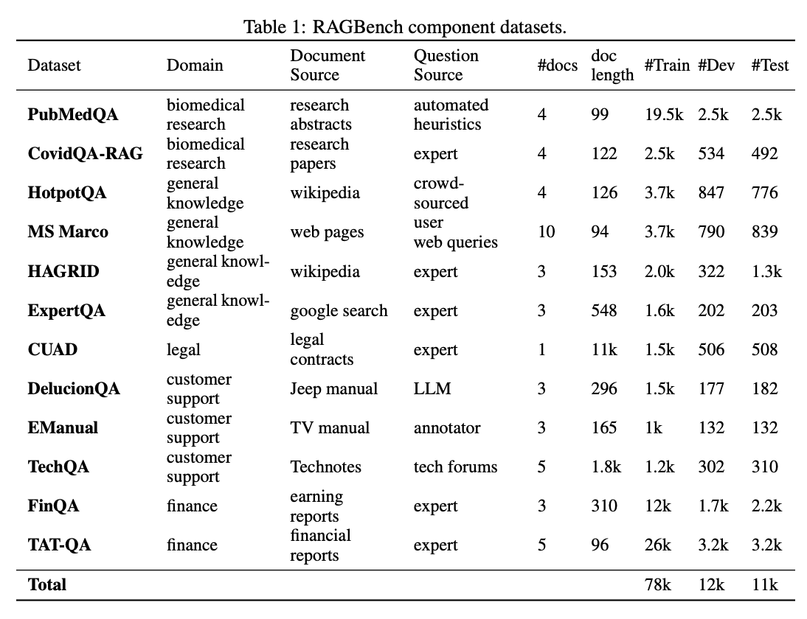
We have specifically chosen these domains based on data availability and their applicability to real-world RAG applications. The diversity of topics within RAGBench allows us to rigorously test the scalability and generalization of our RAG system across various industries, ensuring that the proposed system can function effectively in a wide range of practical use cases.

1.4. Established RAG Workflow
Prior research has delineated a structured workflow for implementing RAG systems, comprising the following key components:
Query Classification: Determining whether a given input query necessitates retrieval to provide an accurate response or requires generation.
Retrieval: Efficiently obtaining relevant documents for the query using methods such as BM25, or LLM-based embedders.
Reranking: Refining the order of retrieved documents based on their relevance to the query, employing techniques like monoT5, monoBERT, or RankLLaMA.
Repacking: Organizing the retrieved documents into a structured format to facilitate better generation outcomes.
Summarization: Extracting key information from the repacked documents to generate a concise and informative response, utilizing extractive or abstractive methods.
Implementing this workflow necessitates careful consideration of several factors:
Document Chunking: Splitting documents into manageable chunks to optimize retrieval quality.
Embedding Selection: Choosing appropriate embeddings to semantically represent document chunks.
Vector Database Selection: Selecting an efficient vector database for storing and retrieving feature representations.

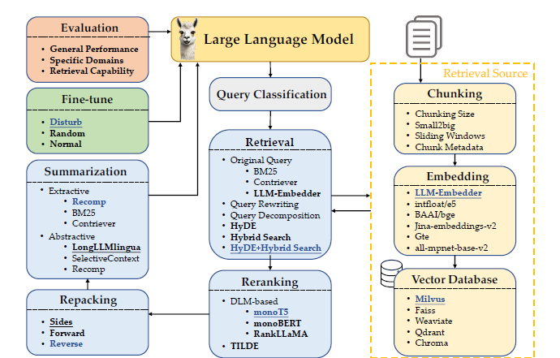

By adhering to this structured workflow and addressing these considerations, RAG systems can effectively enhance the accuracy and relevance of responses in domain-specific applications.

1.5. Proposed RAG Pipeline
The proposed RAG pipeline is designed to reduce hallucinations, enhance the accuracy and relevance of generated responses by integrating an efficient document retrieval mechanism with a large language model (LLM). The system is structured to handle document preprocessing, embedding generation, storage in a vector database, retrieval for response generation and evaluation of the generated response by a different LLM. The key components of the pipeline are outlined below.

1.5.1. Document Preprocessing
To ensure effective retrieval, we employed a sliding window-based chunking approach on the dataset, which consists of 77,009 documents across three data splits: train, validation and test. Each document was segmented using a window size of 4 sentences with an overlap of 1 sentence to maintain contextual continuity between chunks. This method resulted in a total of 367,724 document chunks, which were then processed for embedding generation.

1.5.2. Embedding Selection
To facilitate efficient semantic search, each document chunk was converted into a dense vector representation using all-MiniLM-L6-v2, a 384-dimensional embedding model from the Sentence Transformers library. This model was chosen due to its efficiency in capturing semantic relationships while maintaining a compact representation. As a result, the processed dataset yielded an embedding matrix of size (367724, 384) where each row represents the dense embedding of a corresponding document chunk as the metadata along with the auto index.

1.5.3. Vector Database Selection and Storage
For fast and scalable retrieval, the generated embeddings were normalized and stored in a FAISS (Facebook AI Similarity Search) database, which is optimized for high-speed similarity search over large-scale vector spaces. The normalization step ensures that the embeddings are comparable using cosine similarity, which improves retrieval accuracy.

1.5.4. Retrieval Method
The retrieval phase in our RAG pipeline is responsible for efficiently fetching relevant documents based on user queries. We employ a two-step retrieval approach that leverages FAISS with IVF (Inverted File Index) for Approximate Nearest Neighbour Search followed by Maximal Marginal Relevance (MMR) selection to improve result diversity. This hybrid method ensures that the retrieved documents are not only highly relevant but also diverse, reducing redundancy and improving response quality.

1.5.4.1. FAISS-Based Approximate Nearest Neighbour Search
To efficiently retrieve the most relevant documents, we utilize Facebook AI Similarity Search (FAISS) with Inverted File Index (IVF). FAISS is a highly optimized library designed for fast and scalable nearest neighbour search over large-scale vector spaces. The steps involved in FAISS based ANN Search are as follows.
Query Embedding Generation: The user's query is converted into a dense embedding using the same all-MiniLM-L6-v2 embedding model used during document indexing.
Normalization: The query embedding is normalized to ensure consistent similarity computations.
FAISS Approximate Search: The FAISS index is queried using the Inner Product (dot product) search, which approximates cosine similarity when embeddings are normalized. FAISS efficiently retrieves the top-k nearest neighbours by performing an ANN search on the nearest 1000 vectors using its IVF-based approximate search technique instead of scanning the entire dataset.
Cosine Similarity Computation: The retrieved candidates' embeddings are further normalized and re-ranked based on exact cosine similarity to refine the results.

1.5.4.1.1. Advantages of FAISS Based ANN Retrieval Approach
Scalability: FAISS is optimized for large-scale datasets and can efficiently retrieve top-k nearest documents even from millions of vectors.
Speed: Approximate nearest neighbor search using IVF indexing significantly reduces retrieval time compared to brute-force similarity computations.
Memory Efficiency: The FAISS index enables compressed storage of embeddings, making retrieval efficient without requiring excessive memory.

1.5.4.2. Maximal Marginal Relevance (MMR) for Re-Ranking
After obtaining the top-k retrieved documents from FAISS, we apply Maximal Marginal Relevance (MMR) to ensure the selected documents are both relevant and diverse. MMR works by balancing two objectives:
Maximizing relevance: Prioritizing documents with high similarity to the query.
Minimizing redundancy: Ensuring the selected documents provide complementary rather than repetitive information.
The steps involved in MMR for reranking are as follows.
Compute Cosine Similarity: The top-k documents from FAISS retrieval are sorted by similarity score.
Select the Most Relevant Document: The document with the highest similarity is selected first.
Diversity Penalization: For each remaining document, its similarity to already selected documents is computed, and a diversity penalty is applied.
MMR Score Calculation: The MMR score for each candidate document is computed as: MMR Score = Relevance Score – λ × Diversity Score
where λ is a tuneable parameter that balances relevance vs. diversity (λ selected = 0.8).
Iterative Selection: The document with the highest MMR score is selected in each iteration until the required number of results is reached.

1.5.4.2.1. Advantages of MMR-Based Re-Ranking
Improved Diversity: Reduces redundancy by avoiding near-duplicate documents in the retrieved set.
Contextual Coverage: Ensures selected documents provide broad coverage of the topic rather than focusing on a single aspect.
Enhanced Answer Generation: By incorporating diverse perspectives, MMR helps generate more comprehensive and informative responses.
By combining FAISS-based nearest neighbour search with MMR-based re-ranking, our retrieval approach achieves a highly efficient, scalable, and contextually rich document retrieval process. This method ensures that the retrieved documents are not only semantically relevant but also complementary, which significantly enhances the quality and reliability of the final generated response.

1.5.5. Response Generation
After retrieving the top-k most relevant and diverse documents using the FAISS-based Approximate Nearest Neighbor Search and Maximal Marginal Relevance (MMR) re-ranking method, we proceed to the response generation phase. This phase is responsible for synthesizing a coherent and informative answer based on the retrieved documents while ensuring factual accuracy and relevance to the user's query.

1.5.5.1. LLM Model Selection
For generating responses, we utilize Meta-Llama-3-70B-Instruct, a powerful large language model (LLM) fine-tuned for instruction-following tasks. This model is well-suited for extracting and structuring information from retrieved context, ensuring accurate, context-aware, and coherent responses.

1.5.5.2. Response Generation Prompt and Hyperparameter Tuning
Prompt Construction: We design a structured prompt that instructs the LLM to generate a response exclusively using the retrieved top-k documents while discarding any irrelevant information. The structured prompt is:
You are a helpful assistant providing answers to user queries.
Answer the question using the provided document only.
Choose the relevant information from the provided document that is helpful in answering the question only.
Context: {document}
Question: {question}

This prompt explicitly restricts the model from hallucinating and ensures that all responses are derived strictly from the retrieved context.
Hyperparameter Selection: We configure the text generation with the following parameters:
- Temperature = 0.5: Controls response variability. A moderate value ensures a balance between determinism and creativity.
- Repetition Penalty = 1.03: Discourages redundant text generation, ensuring more concise and meaningful responses.
- Max New Tokens = 512: Restricts the response length to maintain efficiency while allowing sufficiently detailed answers.
Generating the Response: The constructed prompt is then passed to Meta-Llama-3-70B-Instruct, which generates the response based on the retrieved documents.

1.5.5.3. Post-Processing the Generated Response
Once the raw response is generated, we apply the following post-processing techniques to refine and format the response for the response evaluation steps.
- Extract the response text from the generated output by removing any extraneous model-generated tokens or formatting issues.
- Normalize Whitespace and Formatting to improve readability.
- Convert Response into Structured Format: To ensure consistency, the processed response is structured into a dictionary format with well-defined keys and values.

1.5.5.4. Advantages of Our Response Generation Approach
Faithfulness to Retrieved Documents: The model is strictly constrained to generate responses only from the provided documents, reducing hallucinations.
Improved Answer Quality: The combination of retrieved context with LLM-based synthesis ensures detailed, contextually relevant answers.
Scalable and Efficient: The use of a powerful pre-trained model with optimized hyperparameters ensures both speed and quality in response generation.
By integrating RAG with Meta-Llama-3-70B-Instruct, our pipeline ensures that responses are accurate, contextually relevant and structured. This response generation mechanism serves as the final step in our RAG generation pipeline, ensuring high-quality AI-assisted answers for user queries.

1.6. Performance Evaluation Metrics
To assess the effectiveness of our proposed RAG pipeline, we employ the evaluation framework from the paper "RAGBench: Explainable Benchmark for Retrieval-Augmented Generation Systems." This framework enables a detailed analysis of the model's ability to generate factually grounded, explainable, and contextually relevant responses.

1.6.1. Explainability Attributes for Generated Responses
Evaluation in our RAG pipeline involves assessing the alignment between retrieved documents, the user’s query, and the generated response. To achieve this, we utilize a separate LLM model, Meta-Llama3-70b-8192, with a temperature of 0.5, by using the predefined prompt from the RAGBench paper to generates the following defined explainability attributes. The extracted attributes help quantify retrieval quality, response faithfulness, and explainability at a granular level. This ensures that the evaluation remains consistent and aligned with standardized benchmarks for Retrieval-Augmented Generation systems.
Relevance Explanation: Provides a textual justification for why the retrieved documents are relevant to the given query. Helps ensure that the retrieval process aligns with the query intent.
All Relevant Sentence Keys: Identifies specific sentences in the retrieved documents that contribute to answering the question. Enables finer granularity in assessing relevance.
Overall Supported Explanation: Justifies whether the generated response is factually supported by the retrieved documents. Highlights potential gaps where the response may lack proper grounding.
Overall Supported (Binary Metric): A binary (Yes/No) indicator that determines if the generated response is fully supported by the retrieved documents. A critical metric to prevent hallucinations.
Sentence Support Information: Provides sentence-level justifications that map response segments to corresponding supporting sentences in the retrieved documents. Enhances traceability of the generated response.
All Utilized Sentence Keys: Identifies which parts of the retrieved context were actively used by the LLM in generating the final response. Measures how efficiently the retrieved documents contribute to response generation.

1.6.1.1. Post-Processing the Explainability Attributes
Once the raw JSON response is generated by the LLM model, we apply the following post-processing techniques to refine and format the response for the response evaluation steps.
- Extract the response text from the generated output by removing any extraneous model-generated tokens or formatting issues.
- Normalize Whitespace and Formatting to improve readability.
- Convert Response into Structured JSON format if it is not already in JSON format: To ensure consistency, the processed attributes are structured into a JSON format so that they could be fed into the next module.

1.6.2. TRACE Metrics Generation
Building on the extracted explainability attributes, we compute the following key evaluation metrics to systematically assess the effectiveness of our RAG pipeline. These metrics provide a quantitative assessment of retrieval quality, response utility, and factual correctness in generated outputs.
Context Relevance: Measures how well the retrieved documents align with the query intent by measuring the proportion of retrieved sentences that are relevant to the query. This is derived from the Relevance Explanation and All Relevant Sentence Keys attributes and ensures that retrieval focuses on highly relevant and contextually accurate sources. Low relevance points to an inefficient retriever that supplies excess information to the generation model.
Context Relevance = Number of relevant sentences in retrieved documents​
Total retrieved sentences

Context Utilization: Evaluates the extent to which the retrieved content was actively used in generating the response. This is computed using the All Utilized Sentence Keys attribute. Higher scores indicate that the retrieval system is effectively providing useful information for the LLM's response. Low Utilization in combination with low Relevance points to a greedy retriever, while low Utilization alone points to a weak generator that fails to leverage the provided context efficiently.
Context Utilization = Number of retrieved sentences used in the response​
Total retrieved sentences

Completeness: Assesses whether the generated response fully and comprehensively answers the query. This is determined based on Overall Supported Explanation and Sentence Support Information. Aims to ensure that responses are not partial or missing critical information from the retrieved context. It is possible to have high Relevance and high Utilization, but low Completeness when the generator utilizes irrelevant information in the context to produce a low-quality response.
Completeness = Number of relevant sentences used in the response​
Total relevant sentences retrieved

Adherence: Determines whether the response remains faithful to the retrieved documents without introducing hallucinations. This measures the factual consistency of the generated response by checking how much of it is backed by retrieved documents. This is evaluated using the Overall Supported (binary metric) and Sentence Support Information. Helps in identifying instances where the LLM deviates from factual content, ensuring high response integrity.
Adherence = Number of supported response sentences
Total response sentences

1.6.3. Overall Model Performance
To assess the effectiveness of our proposed RAG pipeline, we evaluate the overall model performance by comparing our computed explainability metrics with the ground-truth scores provided in the dataset using the RMSE and the AUC_ROC metrics. This step ensures that both the retrieval and the response generation process align with the expected standards for accuracy, completeness, and contextual relevance.
Root Mean Squared Error (RMSE): RMSE is used to quantify the difference between the computed scores from our model and the ground-truth values from the dataset. A lower RMSE indicates that the model’s outputs are more consistent with human-labeled evaluations. The RMSE is computed using the formula:
$$RMSE=\sqrt{\frac{1}{N}\sum_{i=1}^{N}{}{(Ypredicted-Yctual)}^{2}}$$
where N is the total number of evaluated queries. The lower the RMSE values, the better the model performs.
Area Under the Receiver Operating Characteristic Curve (AUC-ROC): AUC-ROC is used to measure the ability of the model to correctly distinguish between correct and incorrect retrievals or generations. A higher AUC score (closer to 1) indicates that the model performs well in ranking relevant responses higher than irrelevant ones. The ROC curve plots the True Positive Rate (TPR) against the False Positive Rate (FPR) at various threshold settings:
$$TPR= \frac{True Positives}{True Positives+False Negatives}$$
$$FPR= \frac{False Positives}{False Positives+True Negatives}$$
The AUC score is computed as the area under this curve.
The retrieval model is evaluated by comparing the relevance and utilization scores of the retrieved documents with the ground-truth dataset. The LLM response generation is assessed based on adherence, completeness, and support from retrieved documents. The final RMSE and AUC-ROC scores provide a quantitative measure of the overall model reliability, aligning with the RAGBench evaluation framework. A well-performing model will have low RMSE and high AUC-ROC, indicating strong alignment with human evaluations and minimal hallucinations in response generation. This comprehensive evaluation ensures that our RAG system effectively retrieves and generates accurate, explainable, and factually supported responses.

1.7. Experiments

To systematically evaluate the effectiveness of different RAG (Retrieval-Augmented Generation) model configurations, we conducted experiments using five distinct model combinations. Each experiment maintained a consistent evaluation LLM, Llama3-70b-8192, to ensure uniform assessment criteria across all setups. The variations were introduced at different stages of the pipeline, including embedding models, vector databases, retrieval methods, and response models. Below, we detail the configurations and findings of each model tested.

1.7.1. Models Used Across Experiments
Chunking Strategy: Sliding window with 4-sentence chunks and 1-sentence overlap
Evaluation LLM: Llama3-70b-8192
Vector Database: Either FAISS or MILVUS, depending on the experiment
Retrieval Methods: Various indexing and search techniques including Cosine Similarity, Maximum Marginal Relevance (MMR), KNN search, ANN search, IVF indexing, and TF-IDF
Response Models: Varied between Zephyr-7B, Llama-3.1-8B-Instruct, and Meta-Llama-3-70B-Instruct

1.7.1.1. Model 1
Embedding Model: BAAI/bge-base-en
Vector Database: FAISS
Retrieval Method: Inner Product (IP) based search using Cosine Similarity
Response Model: HuggingFaceH4/zephyr-7b-beta
Observations: This setup utilized a widely used embedding model for English-language semantic retrieval. The FAISS vector database, combined with an IP-based Cosine Similarity search, efficiently retrieved relevant chunks. The response model, Zephyr-7B, generated fluent and contextually appropriate responses. This model performed well in general comprehension tasks but at times failed to retrieve nuanced information due to the embedding model's limited capability in capturing long-range dependencies. The response times increased significantly since the complete corpus was searched for each user’s query.

1.7.1.2. Model 2
Embedding Model: Sentence-transformers/all-miniLM-L6-v2
Vector Database: FAISS
Retrieval Method: IP-based Cosine Similarity with KNN=1000
Response Model: meta-llama/Llama-3.1-8B-Instruct
Observations: This model replaced the embedding model with all-miniLM-L6-v2, a smaller and faster alternative since it is a 384-dimensional embedding. The retrieval mechanism used a large KNN=1000 search space to improve recall and retrieval times. The response model, meta-llama/Llama-3.1-8B-Instruct, provided more detailed and structured responses compared to Zephyr-7B. While retrieval recall improved, the precision suffered, leading to some irrelevant passages being retrieved. The response model handled complex queries better but was sometimes verbose.

1.7.1.3. Model 3
Embedding Model: Sentence-transformers/all-miniLM-L6-v2
Vector Database: FAISS
Retrieval Method: IP-based Cosine Similarity with KNN=1000
Response Model: HuggingFaceH4/zephyr-7b-beta
Observations: The retrieval behavior was consistent with Model 2, but Zephyr-7B provided more concise responses. This configuration was better suited for short-form question-answering but struggled with in-depth elaborations. This model was also producing irrelevant responses for longer sentences retrieved.

1.7.1.4. Model 4
Embedding Model: Sentence-transformers/all-miniLM-L6-v2
Vector Database: FAISS with IVF Indexing
Retrieval Method: IVF Indexing with Approximate Nearest Neighbors (ANN=1000)
Reranking Method: MMR Reranking
Response Model: meta-llama/Meta-Llama-3-70B-Instruct
Observations: IVF (Inverted File Indexing) in FAISS was introduced to improve search efficiency. MMR reranking was also applied to diversify the top retrieved results before feeding them to the response model. This model excelled in scalability and retrieval speed while maintaining high retrieval relevance. Meta-Llama-3-70B-Instruct produced the most accurate, context relevant and elaborate responses, making it suitable for complex question-answering tasks. The search accuracy significantly increased compared to FAISS due to IVF approximations. This is considered as our final model for the RAG based Q&A.

1.7.1.5. Model 5
Embedding Model: Sentence-transformers/all-miniLM-L6-v2
Vector Database: MILVUS
Retrieval Method: TF-IDF with Approximate Nearest Neighbors (ANN=1000)
Reranking Method: MMR Reranking
Response Model: HuggingFaceH4/zephyr-7b-beta
Observations: This model replaced FAISS with MILVUS, a cloud-native vector search engine, and used TF-IDF keyword-based search combined with ANN and MMR reranking. MILVUS provided scalability benefits but retrieval quality varied depending on query structure. Zephyr-7B gave fluent but sometimes provided less information-dense responses.

1.7.1.6. Results
The experiment results for all the models tried on the Emanual dataset are shown below. Model-4 is our finalized model as it produces better results comparatively.
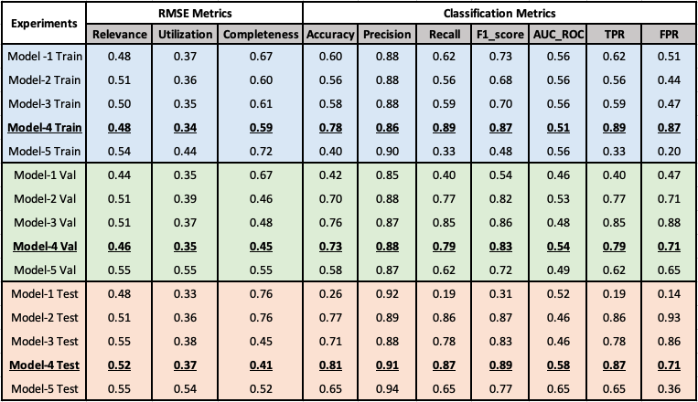

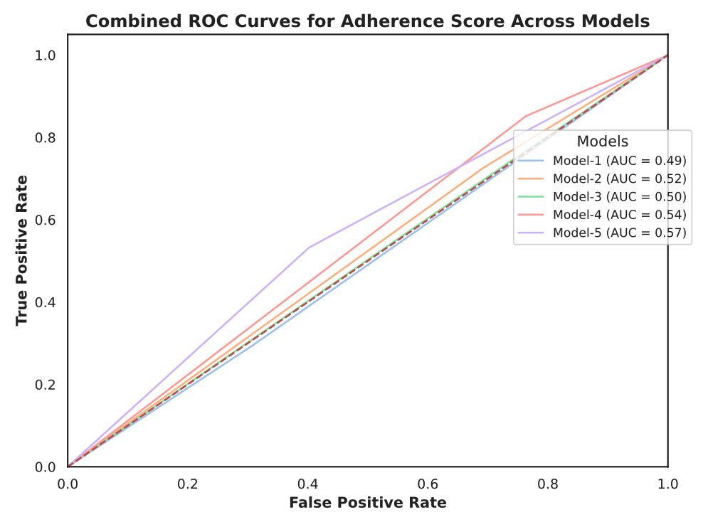

1.8. Challenges
During the development and experimentation of the RAG pipeline, several key challenges emerged, requiring iterative optimization and troubleshooting. These challenges spanned across prompt engineering, post-processing responses, and ensuring compatibility with evaluation models and APIs.

1.8.1. Curating the Prompt for Response Generation
The first challenge was designing an effective prompt for the response generation model. The quality and coherence of the generated responses were highly sensitive to prompt structure. A well-structured prompt significantly improved the relevance and contextual accuracy of responses. Variations in prompt phrasing impacted how the response model interpreted retrieved documents and structured its output. Several iterations of prompt engineering were required to balance conciseness, informativeness, and grounding in retrieved content.

1.8.2. Post-processing Generated Responses and Explainability Attributes
Handling the outputs from the response generation model and structuring explainability attributes for the TRACE metrics pipeline presented another major challenge. The model-generated outputs included JSON-formatted metadata. These outputs had to be formatted correctly to ensure they could be seamlessly fed into the next RAG pipeline for TRACE metric computation. Formatting inconsistencies were a persistent issue, particularly when using the Qwen models for evaluation. In contrast, Llama3-70b-8192 handled JSON formatting smoothly, minimizing the need for post-processing interventions.

1.8.3. Finding a Suitable LLM with API Interface
Finding an LLM that provided robust API access while maintaining consistent behavior across tasks was challenging. Some models had limited inference speed, inconsistent outputs, or API access restrictions, requiring additional experimentation to ensure smooth deployment.
These challenges underscore the importance of prompt design, robust post-processing, and reliable API integration in building an effective RAG pipeline. Addressing these issues systematically led to improvements in retrieval accuracy, response coherence, and automated evaluation workflows.

1.9. RAG Deployment and Applications in Real world
We deployed the RAG project using Gradio Application. Gradio providies an easy-to-use interactive interface for end-users. Gradio allows for quick deployment of machine learning models with minimal code, enabling easy integration of a retriever and generator for real-time question-answering tasks. The user can input queries, and the model retrieves relevant information from a knowledge base to generate accurate and contextually relevant responses. The interface is intuitive, offering a simple web-based UI for users to interact with the RAG system effortlessly.
The deployed Retrieval-Augmented Generation (RAG) system has broad applicability across various real-world domains, including:
Biomedical Research: Enable researchers to efficiently search and summarize scientific literature, facilitating breakthroughs on specific topics.
Knowledge Management Systems: Strengthen knowledge management platforms by empowering users to retrieve and synthesize information from extensive document collections.
Legal Research: Assist lawyers by quickly retrieving relevant legal documents and generating concise summaries, streamlining research efforts.
Customer Service Chatbots: Deliver precise, context-aware responses to customer inquiries, enhancing user satisfaction and overall service quality.
Financial Analysis: Provide detailed, context-rich summaries of financial reports and answer queries related to investments and market trends.

2. Task 2: Benchmarking Large Language Models in Retrieval-Augmented Generation

2.1. Introduction
Large Language Models (LLMs) have demonstrated remarkable capabilities in natural language understanding and generation. However, their inherent limitations, such as outdated knowledge and susceptibility to hallucinations, have led to the development of Retrieval-Augmented Generation (RAG) systems. RAG enhances LLMs by integrating external document retrieval mechanisms, ensuring more accurate, up-to-date, and contextually relevant responses.
Evaluating LLM performance in RAG systems is crucial to understanding their real-world applicability and effectiveness. This study introduces a benchmarking framework that assesses LLMs across four fundamental abilities essential for robust RAG applications: Noise Robustness, Negative Rejection, Information Integration, and Counterfactual Robustness. The benchmark utilizes the RGB dataset. The evaluation is conducted using distinct metrics Accuracy, Rejection Rate, Error Detection Rate, Error Correction Rate.

2.2. Business Use case
Organizations rely on vast document repositories containing policies, reports, and guidelines. A well-benchmarked RAG system ensures that employees receive accurate and up-to-date information, minimizing misinformation and optimizing decision-making.
RAG-powered AI can assist doctors by retrieving relevant clinical guidelines. Noise Robustness ensures that medical AI can extract accurate insights from noisy or unstructured clinical notes, improving diagnostic support.
Law firms and regulatory bodies handle complex legal texts. Evaluating LLMs for Negative Rejection helps ensure that legal AI assistants do not generate misleading responses when relevant case laws or statutes are unavailable, reducing legal risks.

2.3. Dataset
The RGB (Retrieval-Augmented Generation Benchmark) dataset is designed to evaluate LLMs on four essential RAG capabilities: Noise Robustness, Negative Rejection, Information Integration, and Counterfactual Robustness. It contains a total of 1,000 questions, equally split between English and Chinese, ensuring multilingual evaluation. The dataset structure is as follows:
- 600 Base Questions: Used for general performance assessment.
- 200 Information Integration Questions: Designed to test how well an LLM can synthesize information from multiple sources.
- 200 Counterfactual Robustness Questions: Assessing the ability of an LLM to detect and correct factual inconsistencies.
Each question is accompanied by a set of retrieved documents, which can contain relevant, irrelevant, or misleading information. The Negative Rejection subset consists entirely of questions where none of the retrieved documents contain useful information, requiring the LLM to recognize the lack of knowledge and reject answering.
The dataset is publicly available on GitHub (RGB Dataset Repository) and has been detailed in the research paper (RGB Paper).
The RGB dataset is crucial for understanding the real-world performance of RAG systems, allowing researchers to benchmark LLMs across diverse conditions and linguistic contexts.

2.4. Data Preprocessing
- Positive and Negative Sample Selection: The code first identifies the subset of data points in the dataset, handling positive and negative samples separately. For positive samples, it ensures that the number of documents selected meets the required distribution. It also ensures a controlled number of negative samples, especially when the noise rate is factored in.
- Handling Different Types of Data (Positive/Negative/Incorrect): The dataset contains key fields such as query, answer, positive, and negative. These fields are used to generate the input samples. Noise and factually incorrect data are handled by assigning appropriate labels such as:
  - Insufficient information if the generated response is not sufficient to answer the question.
  - Factual errors for responses that are factually incorrect.
  - A check for whether the generated answer matches the ground truth to ensure accuracy.
- Preprocessing: The preprocessing steps ensure that data is adequately prepared, with samples selected for evaluation, and noisy/factually incorrect data is handled effectively. After preprocessing, documents and queries are passed to the LLM (Large Language Model) to generate responses.

2.5. Model Implementation
The model implementation involves several components designed to work together to generate, evaluate, and improve the robustness of responses generated by a language model (LLM) in a noisy or factually inconsistent environment. Below, we break down the various model types, techniques, and steps involved in building and deploying the models.

2.5.1. Noise Robustness Model
The Noise Robustness model aims to evaluate how well the language model can handle noisy or incorrect data and still generate accurate responses. It uses various techniques to inject noise into the dataset and assesses the model's response based on the noise levels.

Key components:
- Positive and Negative Sample Generation: The dataset is processed by selecting both positive and negative samples, which are then used to train the LLM. The noise is injected by selecting a random subset of positive and negative samples with specific noise rates, ensuring the model is exposed to various noisy scenarios.
- Accuracy Checking: The noise robustness model compares the generated answers with the ground truth. Based on this, labels are assigned to evaluate whether the answers are acceptable or erroneous, focusing on:
  - Noise Rate: Varying the noise rate to assess the model's performance in noisy conditions.
  - Accuracy Calculation: The model’s performance is evaluated by calculating the True/False positive and negative rates.

Model Architecture:
- Sampling and Evaluation: The model works by sampling positive and negative instances from the data and using a pre-trained language model (e.g., Hugging Face models) to generate responses. The generated responses are compared to the ground truth and labelled accordingly.
- Output Metrics: The outputs are classified based on labels indicating whether they match the ground truth or contain factual errors, and the overall noise robustness is calculated by the TT ratio (True positive rate).

2.5.2. Rejection Ratio Model
The Rejection Ratio model is a special case of the Noise Robustness model where the noise rate is set to 1, meaning the dataset consists entirely of noisy or irrelevant data. The primary objective of this model is to evaluate how well the language model handles situations where the dataset is completely noisy, and how it makes decisions to "reject" responses when insufficient or incorrect data is provided. The rejection ratio focuses on the model’s ability to assess when to reject an answer based on a lack of confidence or factual errors.

Key components:
- Total Noise: The entire dataset is injected with noise, ensuring that no “clean” data exists. The noise rate is set to 1, which forces the model to deal entirely with noisy or irrelevant data.
- Answer Rejection: Instead of attempting to generate a correct response, the model must learn to detect when the information is insufficient or factually incorrect. When the model detects that the data is not useful for providing a valid response, it will "reject" the output, effectively labelling the result as invalid.
- Rejection Decision: The decision to reject is based on the model's evaluation of the relevance and accuracy of the noisy data. If the generated answer contains insufficient information or factual errors, it is flagged for rejection.

Model Architecture:
- Noise Injection: With the noise rate set to 1, the model is exposed to all negative samples (or noise) in the dataset, making it difficult to generate a correct response.
- Rejection Mechanism: The model evaluates the quality of the response based on the noise level and triggers a rejection if the answer is deemed incorrect or insufficient. The model essentially "refuses" to generate an answer when the input data quality is too low.

2.5.3. Counterfactual Robustness Model
The Counterfactual Robustness model evaluates how well the language model can generate responses when provided with both positive and incorrect (counterfactual) data. The goal is to measure whether the model can distinguish between factually correct and incorrect answers under various conditions.

Key components:
- Query and Answer Evaluation: The query and answer pair is passed through a model that evaluates the correctness of the answer by comparing it with both the ground truth and counterfactual data.
- Correctness Rate: The model introduces counterfactuals (incorrect but plausible answers) and checks how well the LLM can distinguish them from the correct ones.
- Handling Missing Information: If the model’s answer is deemed insufficient, the evaluation process labels the answer as containing "insufficient information."

Model Architecture:
- Retrieval-Augmented Generation (RAG): The Counterfactual model relies on a retrieval mechanism to fetch relevant documents and then uses the retrieved documents alongside the query to generate a response. The LLM model used here is from the Hugging Face API (such as google/gemma-2-27b-it).
- Evaluation of Responses: After generating the response, a comparison with ground truth (correct) and counterfactuals (incorrect) is made. Responses are labelled as either correct, incorrect, or insufficient.

2.5.4. Information Integration Model
The Information Integration model is designed to aggregate data from multiple sources, ensuring that the generated answers are contextually appropriate, factually accurate, and complete. This model integrates noisy and factually incorrect data, compensating for these issues by using both the retrieved documents and the context from the query.
Key components:
- Contextual Integration: The model integrates data from both relevant documents and noisy data sources, ensuring that responses are not only factually correct but also contextually coherent. The documents are pre-processed, and random noise or counterfactual data is incorporated to assess how well the model can handle diverse inputs.
- Document Retrieval: The model uses a retrieval mechanism to select documents from a pool of documents based on their relevance to the query. These documents are then used by the model to generate the response.
- Fact Checking and Labelling: The model integrates fact-checking steps, labeling responses based on factual errors or missing information.
Model Architecture:
- Prompt Template: A prompt template is constructed by combining the query, retrieved documents, and context, which are then passed to the Hugging Face model for response generation.
- LLM Integration: Using the HuggingFaceEndpoint and InferenceClient from Hugging Face, the LLM is invoked to generate the final responses based on the provided documents and query. The responses are then evaluated against ground truth using labels such as "factual errors" and "insufficient information."
- Noise Handling: Noise is injected into the data (both positive and negative samples) and evaluated by comparing the generated responses with the expected ground truth.

2.6. Evaluation Metrics
The performance of LL across the key RAG abilities are evaluated in Accuracy, Rejection Rate, Error Detection Rate, Error Correction Rate. These evaluation metrics, when taken together, provide a comprehensive and nuanced assessment of the LLM's ability to effectively leverage RAG for accurate and reliable information retrieval and generation. They evaluate the model’s performance in the context of noisy data, fact-checking, and correction, offering insights into its robustness across various conditions.

2.6.1. Accuracy (Noise Robustness, Information Integration)
This metric measures the correctness of the LLM's responses when presented with noisy or incomplete information. It focuses on the model's ability to correctly process information despite noise in the input data. We utilize an exact match approach, meaning that a response is considered accurate only if it contains a verbatim match of the ground truth answer. This rigorous criterion ensures a high level of precision in evaluating the LLM's ability to extract and synthesize information effectively.
- Noise Robustness: Evaluates how well the model performs when the data is noisy or incomplete. If the model’s response is consistent with the ground truth despite these noise factors, it is deemed accurate.
- Information Integration: Measures how effectively the model integrates multiple noisy or incomplete data sources to generate an accurate response. The ability to correctly combine different documents and answer the query is crucial for this metric.
2.6.2. Rejection Rate (Negative Rejection, Rejection Ratio)
This metric quantifies the LLM's ability to abstain from answering when the retrieved documents lack the necessary information to provide a reliable response. Successful negative rejection is defined by the LLM's explicit output of the phrase:
"I cannot answer the question because of insufficient information in documents."
This pre-defined response, enforced through instructional prompting, provides a clear signal of the LLM's awareness of its knowledge limitations and prevents the generation of potentially inaccurate or misleading answers.
- Rejection Ratio: The special case where the model operates under high noise conditions (noise = 1). In this case, rejection occurs when the noise level is so high that it would be inappropriate or impossible to generate a correct response.

2.6.3. Error Detection Rate (Counterfactual Robustness)
This metric evaluates the LLM's capability to identify factual inaccuracies present within the retrieved documents. Successful error detection is defined by the LLM's explicit output of the phrase: "There are factual errors in the provided documents."
This predefined response, prompted through instruction, signals the LLM's ability to recognize and flag potentially unreliable information. The model is expected to detect discrepancies in the documents when they deviate from the ground truth.
- Counterfactual Robustness: The model detects responses based on incorrect or counterfactual information. In situations where the answer might seem plausible but is factually wrong, the model is expected to identify and reject those responses explicitly.

2.6.4. Error Correction Rate (Counterfactual Robustness)
In addition to detecting errors, this metric assesses the LLM's ability to provide a correct answer despite the presence of factual inaccuracies in the retrieved documents. This measures the LLM's ability to leverage its pre-trained knowledge to override or correct the misinformation. The model must correct errors in the provided documents and return a response that is faithful to the ground truth, even when the input data is factually incorrect.
- Counterfactual Robustness: This model tests whether the LLM can handle situations where the retrieved documents are factually inaccurate or conflicting with known facts. It evaluates how effectively the LLM applies its internal knowledge to produce a correct response despite errors in the documents.

2.7. Results
Following the execution of our comprehensive testing framework, we obtained detailed performance results for each Large Language Model (LLM) across the four key Retrieval-Augmented Generation (RAG) abilities: Noise Robustness, Negative Rejection, Information Integration, and Counterfactual Robustness. These results provide a quantitative assessment of each LLM's ability to effectively leverage retrieved information, navigate noisy or incomplete contexts, and identify and mitigate factual errors.

Noise Robustness
Noise Ratio | 0 | 0.2 | 0.4 | 0.6 | 0.8
Mistral-7B-Instruct-v0.3 | 99 | 98 | 97 | 96.77 | 90.67
Qwen2.5-72B-Instruct | 97.5 | 87.8 | 95.5 | 94 | 88
DeepSeek-R1-Distill-Qwen-32B | 99.7 | 99 | 98.3 | 93.67 | 93

2.7.1. Noise Robustness Concept
Noise robustness measures how well an LLM can extract useful information from noisy documents.
- Noisy documents = Relevant but missing the actual answer.
- A high noise ratio (e.g., 0.8) means more noisy documents are mixed with relevant ones.

How Accuracy Changes with Noise
Model | Accuracy at 0 Noise | Accuracy at 80% Noise | Drop (%)
Mistral-7B-Instruct-v0.3 | 99 | 90.667 | 8.33%
Qwen2.5-72B-Instruct | 97.5 | 88 | 9.5%
DeepSeek-R1-Distill-Qwen-32B | 99.7 | 93 | 6.7%

Key Observations from the Table
- DeepSeek-R1-Distill-Qwen-32B is the most robust model.
  - It starts at 99.7% and drops to 93%, showing the smallest accuracy decline (6.7%).
  - This suggests it is better at handling noisy documents.
- Mistral-7B-Instruct-v0.3 performs well but shows a slightly higher drop (8.33%).
  - Its accuracy remains above 90%, even at 80% noise, indicating strong resilience.
- Qwen2.5-72B-Instruct shows the largest accuracy drop (9.5%).
  - Despite starting at 97.5%, it drops to 88%, suggesting it is more affected by noise.

Based on the above results, we conclude the following:
- This shows LLMs struggle with noise, and some degrade faster than others
- Higher noise levels significantly impact all models, showing limitations in handling irrelevant information.
- Retrieval-Augmented Generation (RAG) helps but isn't perfect, especially at high noise.

Why Does Noise Impact LLM Performance?
The decline in accuracy as noise increases is due to:
- Long-Distance Information:
  - The question and answer appear far apart in the documents, making it harder for the model to connect them.
- Evidence Uncertainty:
  - Noisy documents contain speculative or misleading information, which can confuse the model.
- Concept Confusion:
  - The model misinterprets related but incorrect information, leading to errors.
Conclusion & Insights
- All three models demonstrate strong noise robustness, maintaining 88%+ accuracy even at high noise levels.
- DeepSeek-R1-Distill-Qwen-32B is the most resilient, with the smallest performance drop.
- Noise significantly impacts accuracy, highlighting the need for improved retrieval and reasoning mechanisms.
Negative Rejection

Model Name | Noise Ratios =1 (Accuracy ) | Rejection Rate
Mistral-7B-Instruct-v0.3 | 41 | 4.5
Qwen2.5-72B-Instruct | 58.2 | 18.2
DeepSeek-R1-Distill-Qwen-32B | 37 | 10.3

2.7.2. Negative Rejection
Measures how well an LLM rejects answering when provided only with irrelevant (noisy) documents.
- Ideal Behavior: The LLM should respond with:
"I cannot answer the question because there is insufficient information in the documents."
Why It Matters:
- A low rejection rate suggests the model hallucinates answers instead of rejecting them.
- A higher rejection rate means the model is better at recognizing when it lacks sufficient information.
Observation:
- Qwen2.5-72B-Instruct has the highest rejection rate (18.2%)
  - Most reliable at refusing to generate misleading answers when faced with noise.
  - Also has the highest accuracy (58.2%), suggesting it is better at distinguishing valid from noisy data.
- DeepSeek-R1-Distill-Qwen-32B has a moderate rejection rate (10.3%)
  - Performs better than Mistral but worse than Qwen2.5, indicating some susceptibility to incorrect responses.
- Mistral-7B-Instruct-v0.3 has the lowest rejection rate (4.5%)
  - This means it rarely refuses to answer, even when it lacks reliable information.
  - It is most prone to hallucinations, which reduces trust in its responses.
Challenges in Negative Rejection
- LLMs struggle to strictly follow instructions.
  - Even when explicitly instructed to reject, they often generate unpredictable responses.
  - This makes it difficult to detect when an LLM should refuse to answer.
- Models can be misled by noisy information.
  - Example: If a noisy document mentions a director's name without confirming their role, the LLM may incorrectly infer they directed a movie.
- Concept Confusion Increases Mistakes.
  - Example: If the model retrieves information about the 2018 Winter Olympics, but the question asks about 2022, it may still generate an incorrect answer.
Conclusion & Insights
- Qwen2.5-72B-Instruct is the most reliable in rejecting incorrect answers.
- Mistral-7B-Instruct is the most prone to hallucinations, making it less suitable for high-risk scenarios where misinformation is critical.
- Future Improvements Should Focus On:
  - Stronger adherence to explicit rejection instructions.
  - Better filtering of uncertain or misleading evidence.
  - More robust retrieval-augmented generation (RAG) mechanisms

Information Integration

Noise Ratio | 0 | 0.2 | 0.4
mistralai/Mistral-7B-Instruct-v0.3 | 73 | 65 | 57
Qwen/Qwen2.5-72B-Instruct | 92 | 87.8 | 85.6
deepseek-ai/DeepSeek-R1-Distill-Qwen-32B | 81 | 80 | 78
Key Observations
- Qwen2.5-72B-Instruct performs best (92% accuracy)
  - This model has the strongest ability to extract and integrate relevant information when no noise is present.
  - Suggests better comprehension and retrieval processing compared to the other models.
- DeepSeek-R1-Distill-Qwen-32B achieves moderate accuracy (81%)
  - Performs well but is significantly lower than Qwen2.5, indicating some struggles with understanding or fusing multiple pieces of information.
- Mistral-7B-Instruct-v0.3 has the lowest accuracy (73%)
  - Less effective at using available information, even when no noise is present.
  - Suggests weaker reasoning or document comprehension abilities.
Challenges in Information Integration (Based on Testbed Analysis)
- LLMs struggle to fully utilize information, even in clean data settings.
  - The highest accuracy (92%) is still below perfect performance, suggesting limitations in information fusion.
  - In other test settings, accuracy drops to 60% (English) and 67% (Chinese), highlighting a fundamental weakness.
- Adding noise significantly reduces performance.
  - When the noise ratio increases, accuracy drops to 43% (English) and 55% (Chinese).
  - Suggests that models have difficulty distinguishing relevant from irrelevant information.
- Complex questions are harder for RAG models.
  - Information from multiple documents can act as “noise” to each other.
  - This makes it difficult for the model to extract only the correct data points and integrate them into a meaningful answer.
Conclusion & Insights
- Qwen2.5-72B-Instruct is the best at integrating information accurately.
- Mistral-7B-Instruct struggles the most, even without noise.
- LLMs face significant performance degradation when noise is added, especially for complex questions.
2.7.3. Future Improvements Needed
- Better multi-document information fusion to enhance reasoning.
- Stronger noise filtering mechanisms to differentiate relevant vs. irrelevant information.
- More advanced retrieval strategies to prevent confusion between different sources.
Counterfactual Robustness
Model Name | Without Doc  (Accuracy ) | With Positive Doc (Accuracy ) | Error Detection Rate | Error Correction Rate
Qwen2.5-72B-Instruct | 75 | 13 | 2 | 33.66
DeepSeek-R1-Distill-Qwen-32B | 96 | 84 | 8 | 25.66
Mistral-Nemo-Instruct-2407 | 72 | 7 | 0 | 0

Severe Accuracy Drop with Counterfactual Documents (ACC_doc)
- All models suffered drastic performance drops when presented with incorrect documents.
- Qwen2.5-72B-Instruct from 91% to 17%.
- Mistral-Nemo-Instruct-2407drops from 72 % to 7%.
- This suggests LLMs rely heavily on retrieved documents, even when they contain false information.
Poor Error Detection (ED & ED)*
- Error detection (ED) is very low, with most models scoring under 10%.
Key Takeaways from Counterfactual Robustness
- LLMs fail to reject false information, even when they contain correct internal knowledge.
- Existing RAG models lack built-in fact-checking mechanisms.
- Potential Fix: Implement truthfulness verification layers in retrieval pipelines.
Final Thoughts
- ChatGLM2-6B struggles with information integration, mainly due to:
  - Answer merging (28%)
  - Ignoring sub-questions (28%)
  - Misalignment (6%)
- LLMs are vulnerable to misinformation:
  - Drastic accuracy drops when faced with counterfactual data.
  - Weak error detection mechanisms make them easily misled.
  - ChatGPT-en performs best at error correction (57.14%), but still struggles.
Potential Solutions
- Chain-of-Thought (CoT) reasoning: Break multi-part questions into distinct logical steps.
- Enhanced retrieval filtering: Detect and remove misleading documents before response generation.
- Post-generation fact-checking: Cross-check answers with multiple knowledge sources.
Overall Insights
- Noise Robustness: Noise significantly impacts accuracy, highlighting the need for improved retrieval and reasoning mechanisms.
- Negative rejection remains a major challenge – LLMs tend to generate misleading answers instead of rejecting questions with insufficient information.
- Information integration is weak, even without noise, limiting LLMs' ability to answer complex questions accurately. Common errors in multi-part questions include merging, ignoring, and misalignment.
- LLMs struggle with counterfactual robustness, failing to detect and correct misinformation effectively.

3. Conclusion
The study assessed four key capabilities of Retrieval-Augmented Generation (RAG) in Large Language Models (LLMs):
- Noise Robustness – How well LLMs handle irrelevant or noisy retrievals.
- Negative Rejection – The ability to reject misleading or irrelevant retrieved documents.
- Information Integration – How effectively LLMs combine retrieved data without confusion.
- Counterfactual Robustness – The ability to detect and correct factual errors in retrieved content.

To measure these, the authors created the Retrieval-Augmented Generation Benchmark (RGB) using:
• Latest news articles to simulate real-world scenarios.
• External documents from search engines to test retrieval relevance and reliability.

Key Findings
- LLMs struggle in all four RAG abilities
- The experimental results show serious limitations in handling misinformation, integrating information, and rejecting irrelevant data.
- Counterfactual Robustness is weak
- As seen in Table 7, LLMs heavily rely on retrieved data, even when it contradicts their internal knowledge.
- Accuracy drops drastically (e.g., ChatGPT-en from 89% to 9%) when exposed to counterfactuals.
- Error Detection & Correction Rates are Low
- Error detection (ED) remains below 10%, meaning LLMs rarely catch factual errors in documents.
- Even advanced models like ChatGPT-en only correct 57.14% of errors, indicating a lack of verification mechanisms.

Information Integration Challenges
- The error analysis of ChatGLM2-6B (Table 6) highlighted three major issues:
  - Merging errors (28%) – Combining answers incorrectly.
  - Ignoring errors (28%) – Overlooking part of the question.
  - Misalignment errors (6%) – Mixing up sources.
- These errors suggest LLMs fail to handle multi-faceted queries properly.
- Implications for RAG Development
  - Current RAG systems are not reliable enough for critical applications (e.g., legal, medical, fact-checking).
  - LLMs can be misled by misinformation, making fact-checking layers essential.
  - Retrieval filtering and better reasoning models (e.g., Chain-of-Thought prompting) are needed to improve response accuracy.

Final Thought
The paper highlights a major gap: RAG is not yet a foolproof solution for knowledge augmentation in LLMs.
- Future research must focus on improving robustness, verification, and information synthesis.
- Blind reliance on retrieved documents can lead to misinformation.
- Careful design and safeguards are necessary for real-world applications.

4. References
- Searching for Best Practices in Retrieval-Augmented Generation
- RAGBench: Explainable Benchmark for Retrieval-Augmented Generation Systems
- https://github.com/chen700564/RGB/tree/master/data
- https://arxiv.org/pdf/2309.01431

